The Manuscript Title Maximum 18 Words [14 Pt., TNR, Bold, Center]
Author Name^{1),*}, Author Name²⁾ [size 12pt, bold, center]
¹⁾Author Affiliation (Study Program, Institution, Country) 1 [11pt size, center]
²⁾Author Affiliation (Study Program, Institution, Country) 2 [11pt size, center]
*Correspondence: email_correspondence [size 11 pt, center]
ABSTRACT
[TNR font size 10pt, italic, single spacing, and line spacing options before and after 6pt] The abstract must reflect the overall substance of the article. It should include a concise statement of the research problem, objectives, methodology, key findings, and conclusions. To ensure conformity with this format, authors are advised to copy each relevant section from the prepared manuscript and paste it into the appropriate sections of the template. The abstract should not exceed 200 words. The maximum length of each article is twelve (12) pages. Authors must ensure that the manuscript strictly follows the template required by the JOINME Journal.
Keywords: Keywords 1; Keywords 2; Keywords 3
This is an open access article under the CC - BY license.

INTRODUCTION (11pt size)
[TNR font size 11 pt , spacing 1, and line spacing options before and after 6 pt] The introduction should clearly present the research background, problem statement, and the gap between existing conditions and expected outcomes. It must be supported by relevant theories, concepts, and recent empirical studies. The section should emphasize the novelty and contribution of the research, highlighting its innovative aspects. The introduction should conclude with a clear statement of the research objectives.
All citations must be managed using reference management software such as Mendeley Desktop and formatted according to the American Psychological Association (APA) 7th Edition style. This ensures accuracy and consistency in both in-text citations and the reference list.
In-text citations should follow the parenthetical format (author, year). For example: a single author (Kapsetaki, 2026), two authors (Yuhana & Fajari, 2025), and three or more authors (Asriyadin et al., 2021). Multiple references should be separated by semicolons, e.g., (Anggriani et al., 2024; Hamash et al., 2024). Narrative citations may also be used, for example: According to Adiansha et al., (2025), all citations should be managed using Mendeley Desktop.
All sources cited in the text must be included in the reference list. A minimum of 15 references is required, with at least 70% derived from primary sources, preferably peer-reviewed journal articles with DOIs, published within the last 10 years.

METHOD (11pt Size)
TNR font size 11 pt, spacing 1, and line spacing options before and after 6 pt ] The methods section must be written concisely, clearly, and systematically. It should include the research approach, research subjects, research design, research instruments, data collection techniques, and data analysis procedures. This section should not contain theoretical explanations. If required, an instrument blueprint table, research materials, or statistical formulas that are not commonly used may be included.
Equations must be written using the equation editor format. If multiple equations are used, they should be numbered sequentially. Equation numbers must be placed on the far right margin, such as (1), (2), and so on. An example of equation formatting is presented in Equation (1):
 | $$F=m∙a$$ | (1)
All explanations of variables and symbols in equations must be written in paragraph form and should not be listed vertically.

RESULTS AND DISCUSSION (11pt Size)
[TNR font size 11 pt, spacing 1, and line spacing options before and after 6 pt] To facilitate readers’ understanding, the Results and Discussion are presented in a single integrated section. Each research finding should be directly interpreted and discussed in relation to relevant theoretical frameworks and compared with previous studies. This section should not be separated into different chapters or sub-sections. The results presented represent the final outcomes of the study; therefore, detailed statistical procedures such as calculations and hypothesis testing do not need to be included.
Research findings may be presented using tables, figures, and graphs to improve clarity. All tables and figures must be described, explained, and commented on in the text prior to their presentation. Examples of table and figure formats are provided in Table 1 and Figure 1.
Table 1. Example Table Format
No | Description | Information
1 | Description 1 | Description 1
2 | Description 2 | Description 2
3 | Description 3 | Description 3
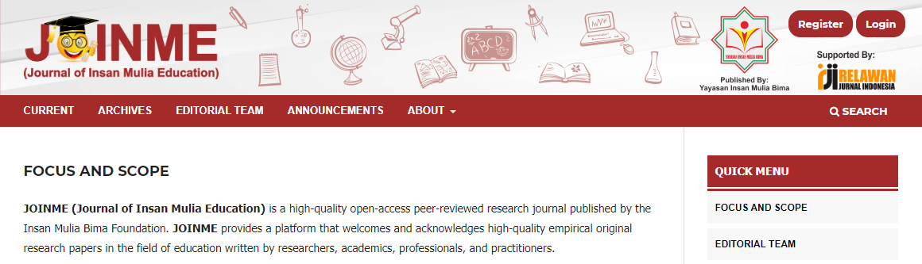
Figure 1. Example Image
The discussion aims to interpret and give meaning to the research results in accordance with the theory used, not simply to explain the findings. The discussion should be enriched by referencing or comparing previous research published in accredited or reputable scientific journals. It is also recommended that the discussion include integrating the research results into established theories or knowledge, developing new theories, modifying existing theories, and including the implications of the research results.

CONCLUSION (11pt size)
[TNR font size 11 pt , single spacing, and line spacing options before and after 6 pt] The conclusion section should be written in a single paragraph and not in bullet points. It provides a concise summary of the results and discussion in relation to the research objectives. Based on these elements, key ideas are derived that represent the essence of the research findings.
Bibliography (Size 11)
Adiansha, A. A., Syarifuddin, S., Syarifudin, S., Diana, N., & Asriyadin, A. (2025). The Impact of Integrating the Wordwall Website in Student-Centered Learning on Numeracy Problem-Solving Skills in Elementary Schools. International Journal of Information and Education Technology, 15(9), 1797–1803. https://doi.org/10.18178/ijiet.2025.15.9.2381
Anggriani, L. A., Hasnawati, H., & Nurhasanah, N. (2024). Development of Ethnoscience-Based Teaching Materials in Class V Elementari School. Insights: Journal of Primary Education Research, 1(1), 1–10. https://doi.org/10.59923/insights.v1i1.68
Asriyadin, A., Yulianci, S., Kaniawati, I., & Liliawati, W. (2021). Improving student character and learning outcomes through a neuroscience approach based on local wisdom. 050027. https://doi.org/10.1063/5.0043350
Hamash, M. A., Mohamed, H., & Tiernan, P. (2024). Developing a New Model for Achieving Flow State in STEAM Education: A Mixed-Method Investigation. Sains Humanika, 16(3), 101–111. https://doi.org/10.11113/sh.v16n3.2163
Kapsetaki, M. E. (2026). Trends and impact of single-author publications among vascular surgeons in the UK. Scientometrics. https://doi.org/10.1007/s11192-026-05604-2
Yuhana, Y., & Fajari, L. E. W. (2025). Cross-disciplinary effects of problem-based learning on problem-solving skills in mathematics and beyond: A comprehensive meta-analysis and bibliometric. Eurasia Journal of Mathematics, Science and Technology Education, 21(11), em2732. https://doi.org/10.29333/ejmste/17345

